Kinesis data Analatyics:

Step1: Create a data stream

Step2: After created the stream create the role

The roles are:

Amazon s3 full access

Amazon kinesis full access

Amazon kinesis firehose full access

Awslambda full access

Cloud watch full access

The role name is :

Step3: Create the kinesis application by choosing the run time as “Legacy SQL”

Step4: configure the source stream

Step5: install python in the cmd prompt

Step6: runt the stock .py

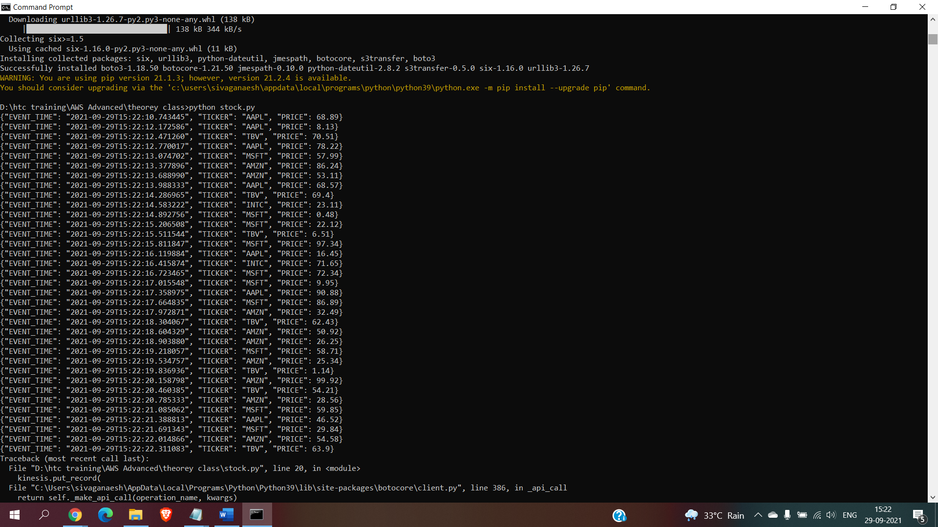

Step7: click on the discover schema in the data analaytics

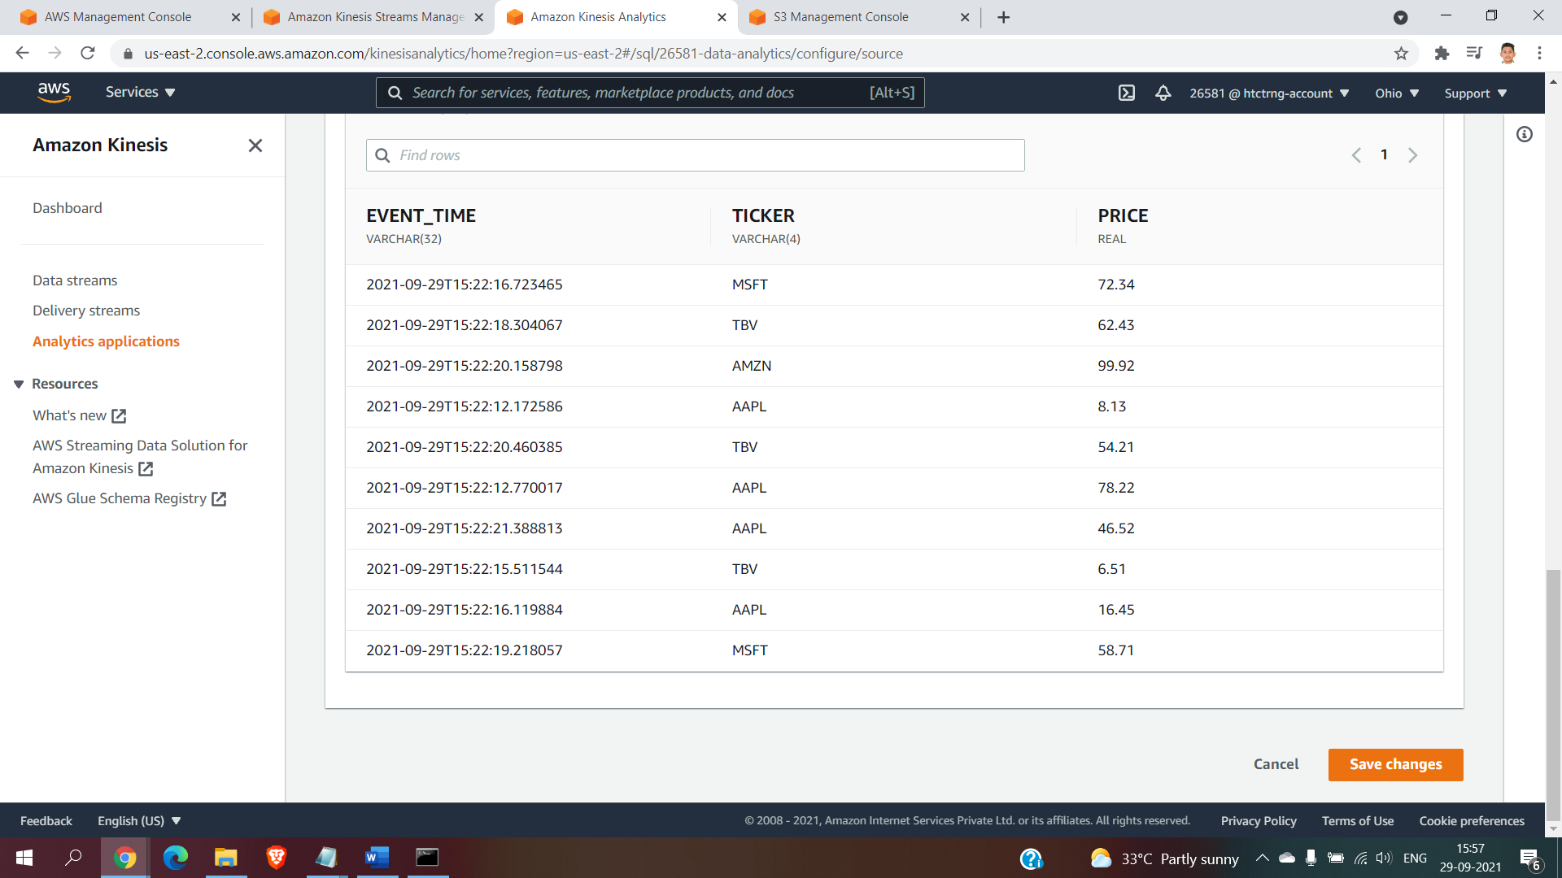

Step8: click on save changes

Step9: page after click on save changes

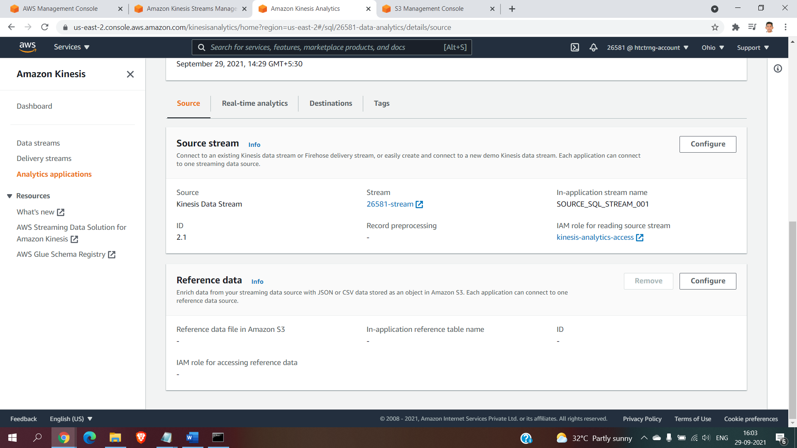

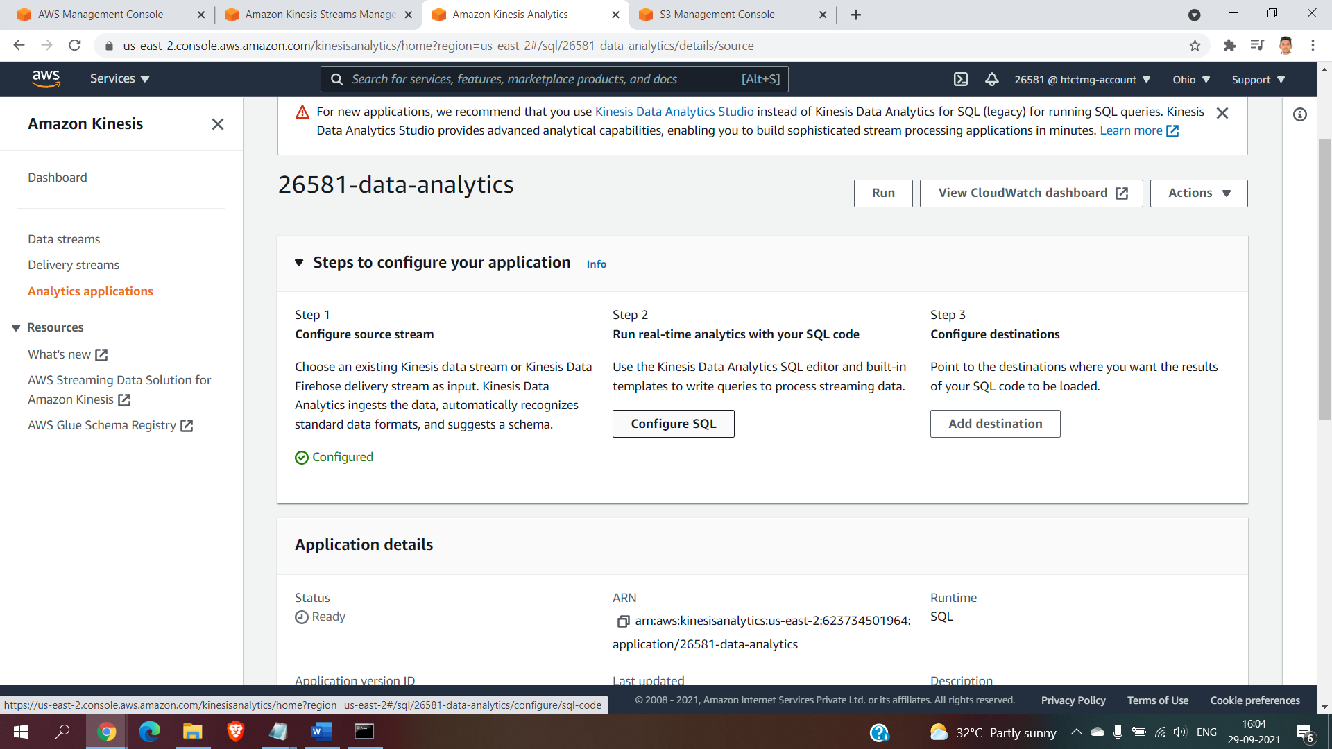

Step10: configure the sql

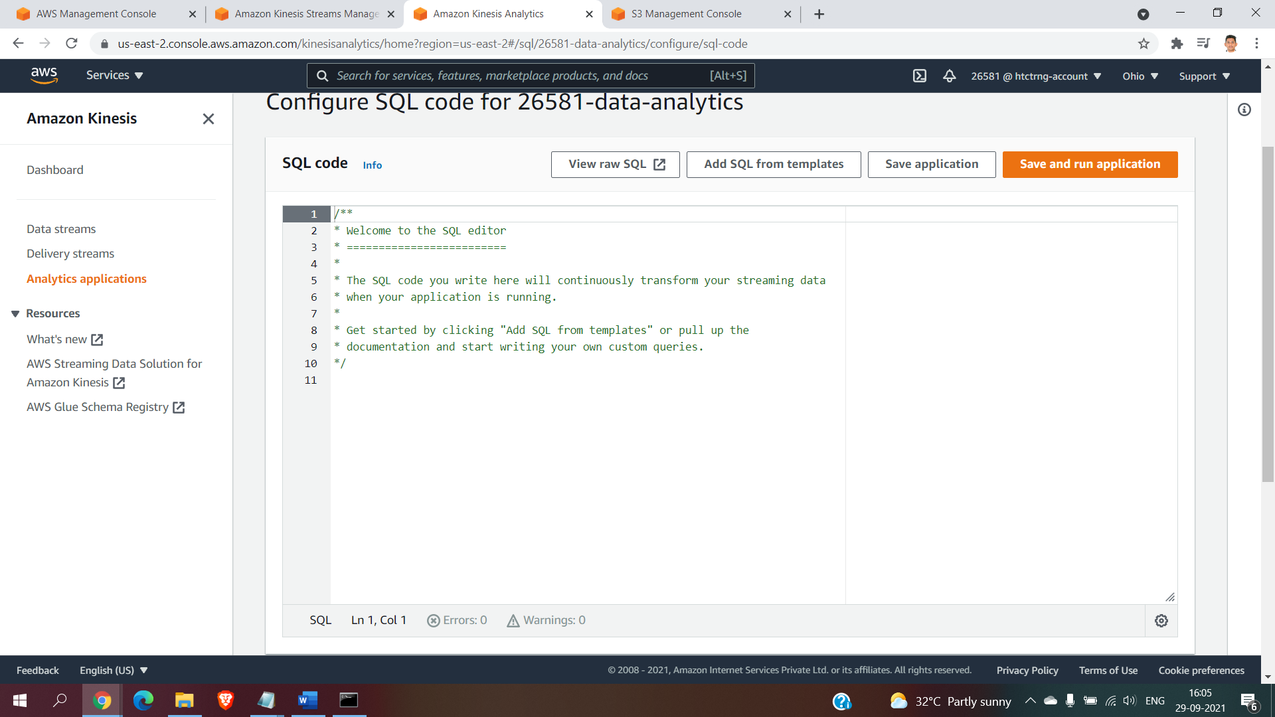

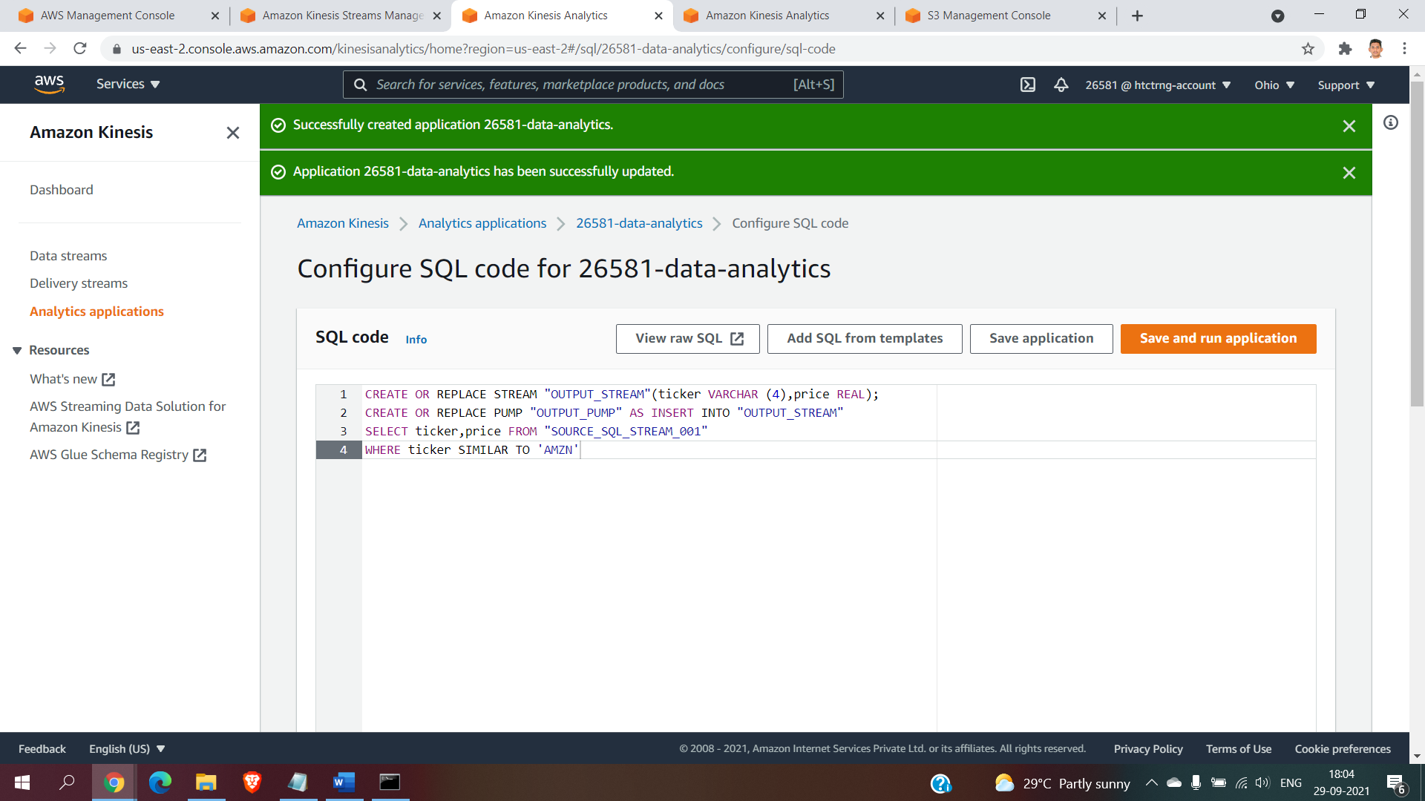

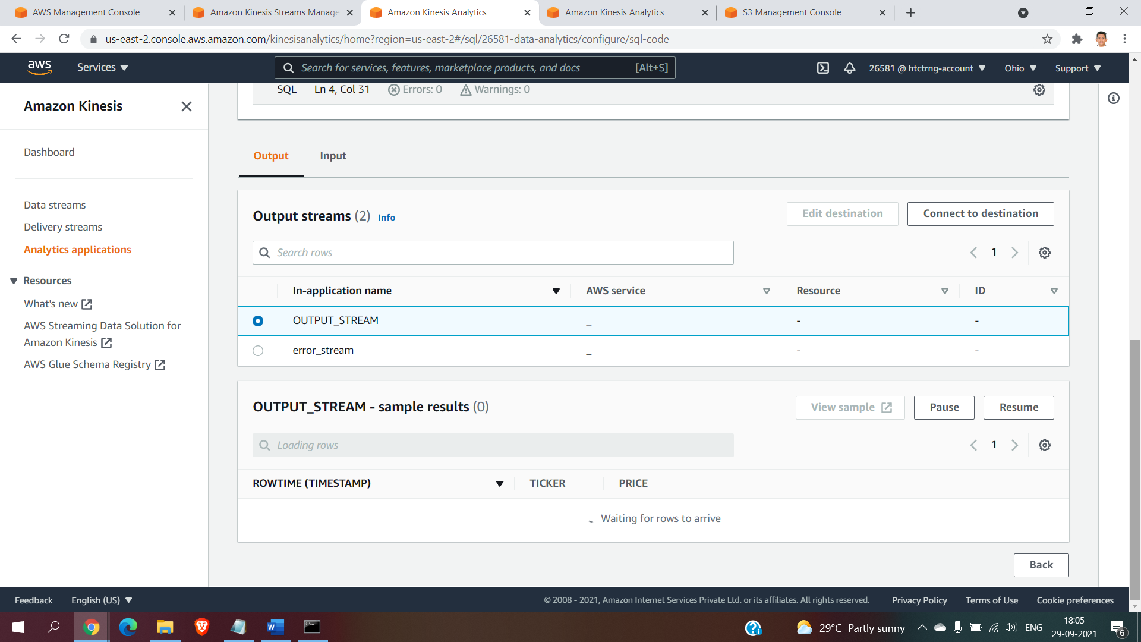

Run the python code and click on the run and save sql 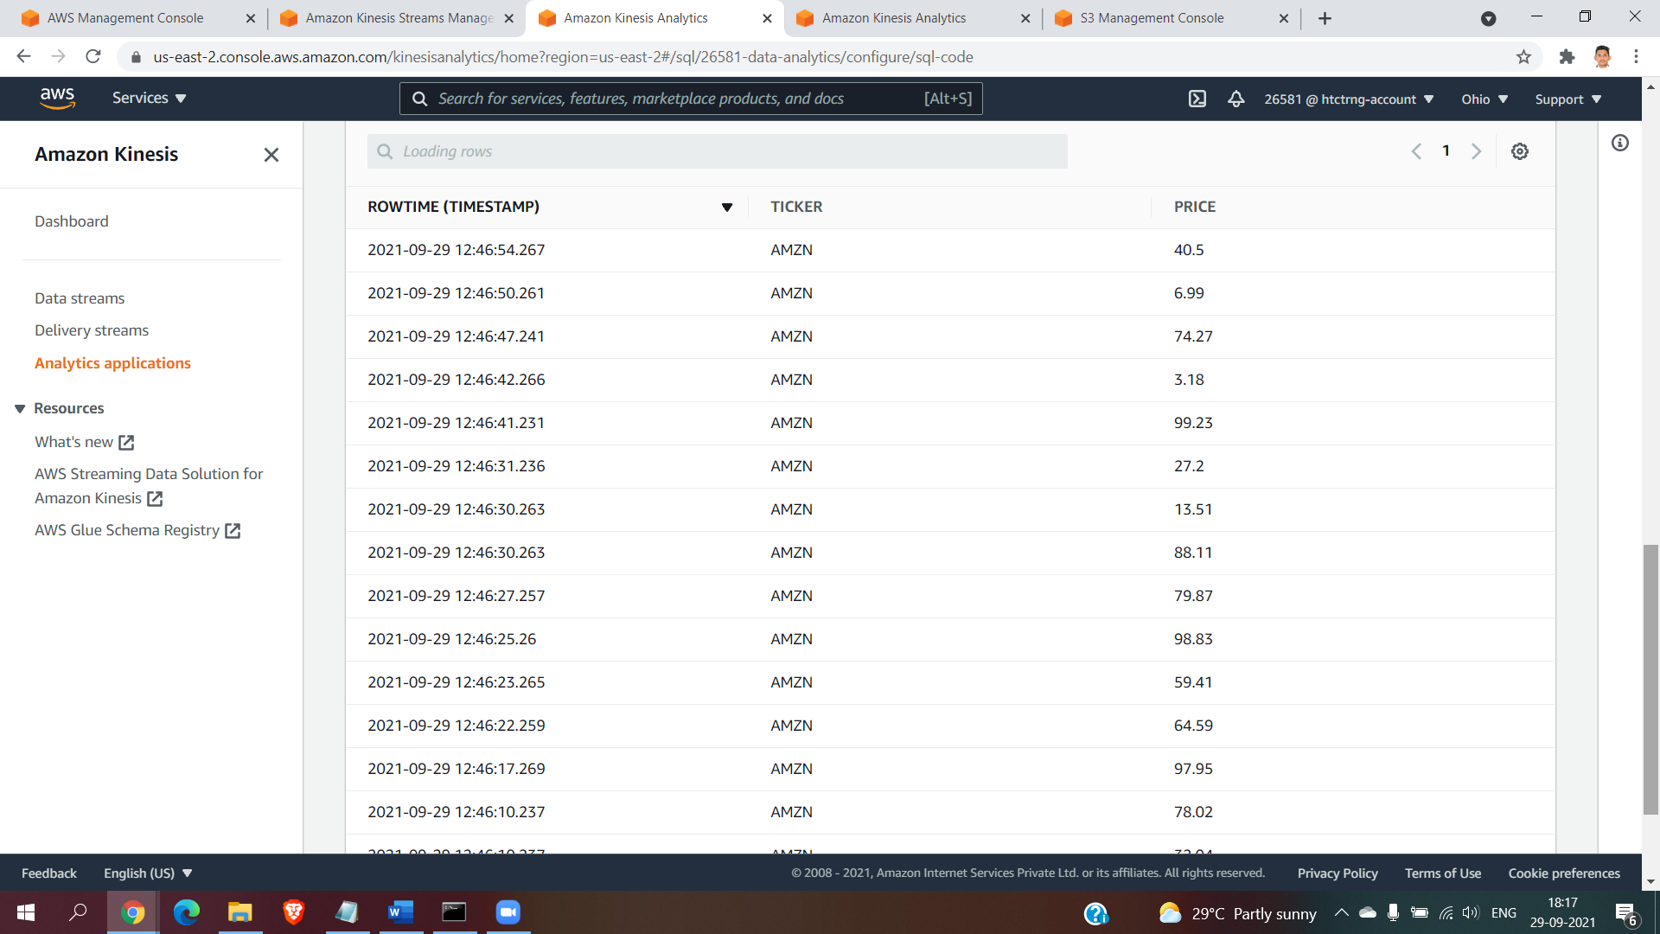

Create an bucket named as “26581-bucket”

Create an datafirehose and choose the destnitaion s3 bucket

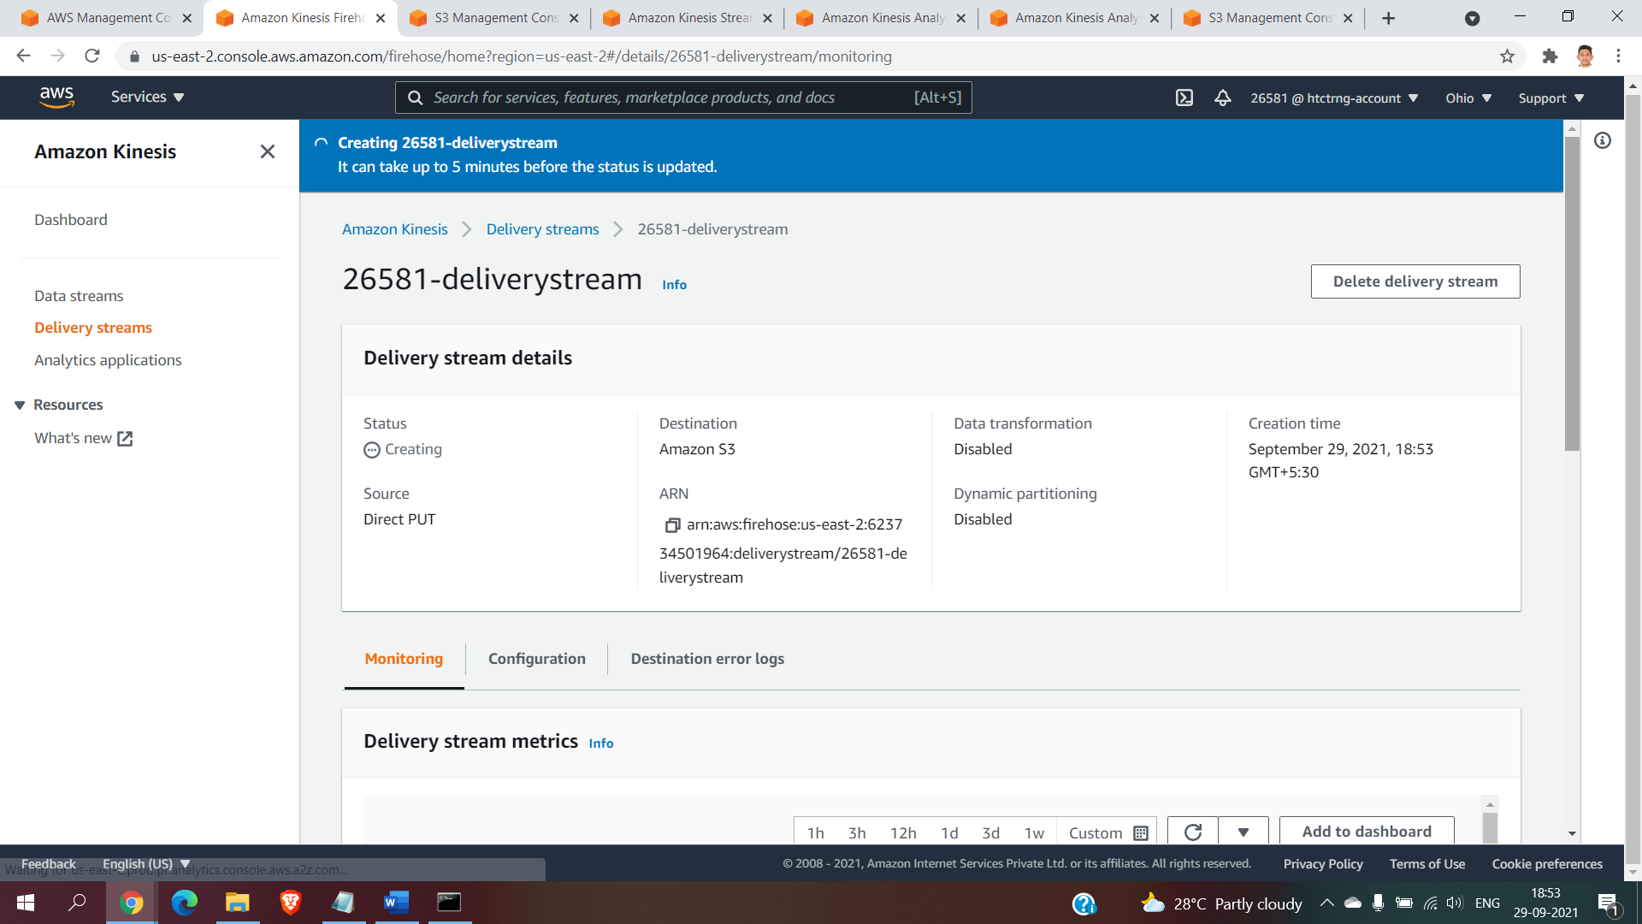

Configure destination for 26581-data-analytics

Choose kinesis data firehose delivery system

Browse the stream in the desired location

Access permissions for writing output stream

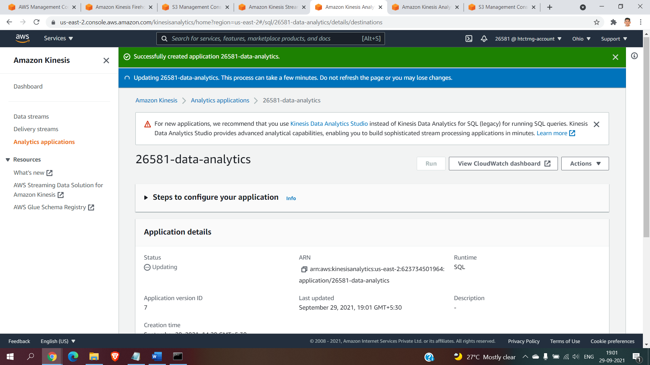

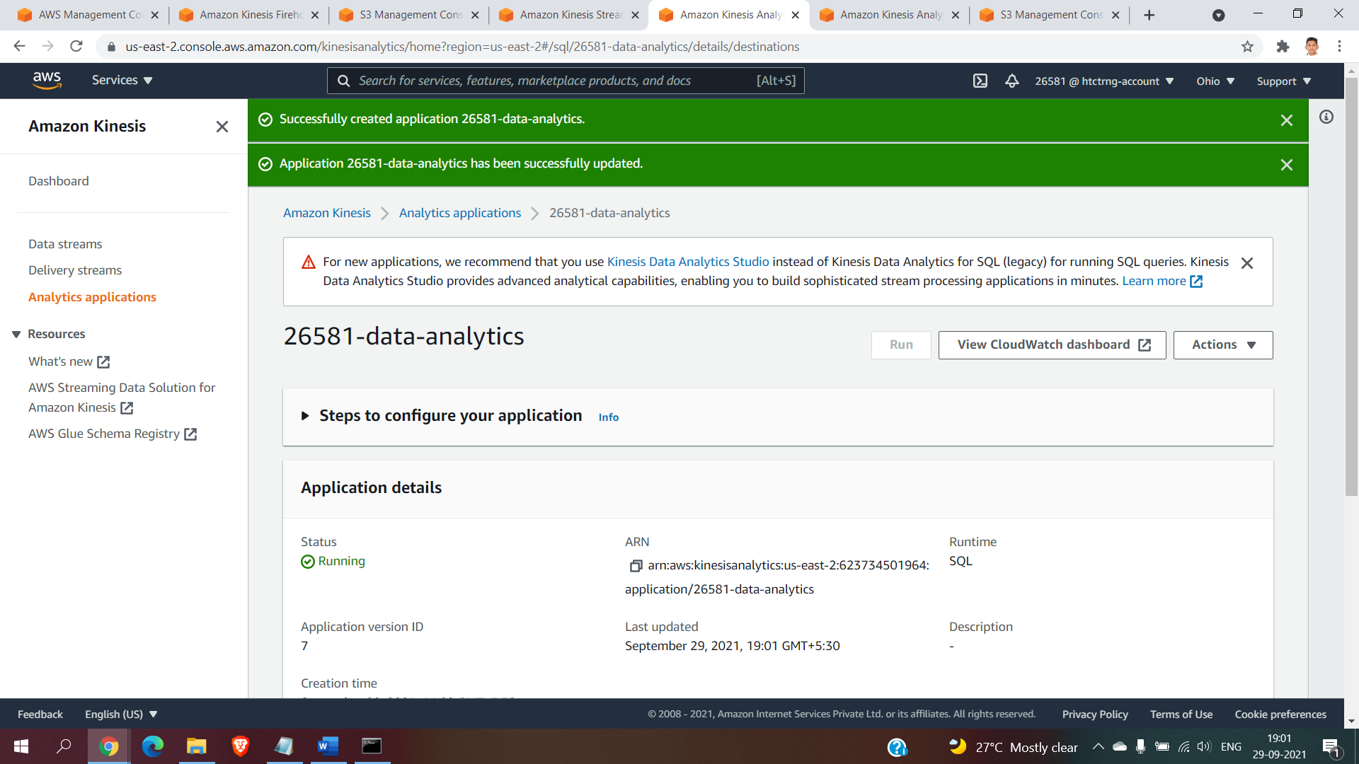

Check it inside the bucket

